We haven't created an EA to load Pocket Options OTC yet. You currently need a subscription from EABiBOT to access any OTC charts.

GO to <https://mt2bo.live/eabibot> to download the EABiBOT.

Once You have all the Apps installed you will need to set them up.

1st go back to your MT5 app and Open it.

Then activate the EABiBOT on a chart then click Open Charts.

First open a chart doesn’t matter which one you use, Because EABiBOT will only be used to load the OTC Charts on Pocket Options

Click File then Chart Window.

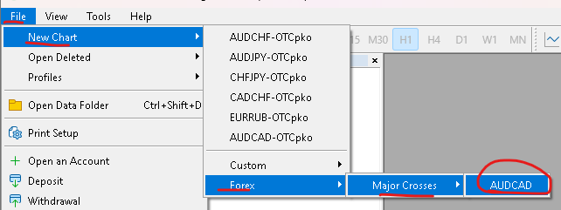

Next Load the EABiBOT on that chart, Right click Expert Advisor and expand till you see the EABiBOT and right click and add to chart.

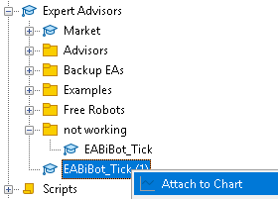

Next a Popup window will open click on the Common Tab and Check both off

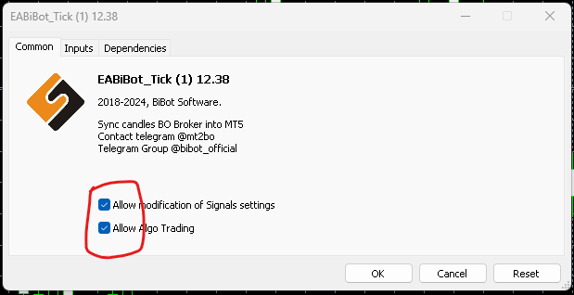

Then click the Inputs Tab and if you have a License then input, if no license then Demo will load. I will show you Both Demo and Full License.

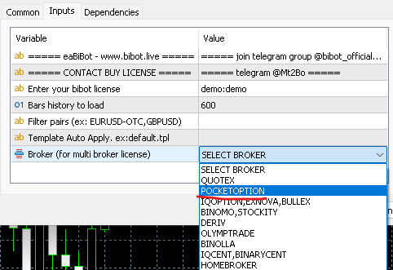

Once it loads click OPEN CHART

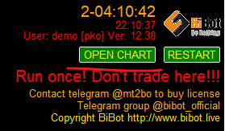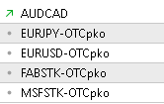

EABiBOT will only load 4 OTC charts in Demo Mode, so you can only Pick 2 charts so lets select both OTC currency charts, the other charts will also load but trading doesn’t work, not sure why but this doesn’t work.

Right Click the EURJOY chart and click Chart Window

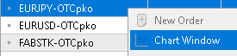do the same for the other Currency chart

At this point you will have 3 charts, you can Minimize the AUDCAD chart as we will not need this anymore.

Now once the charts are loaded change Timeframes by right clicking on the chart and select the 1-minute timeframe.

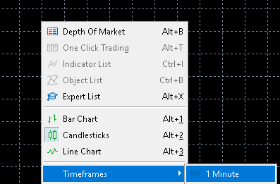do this for both charts

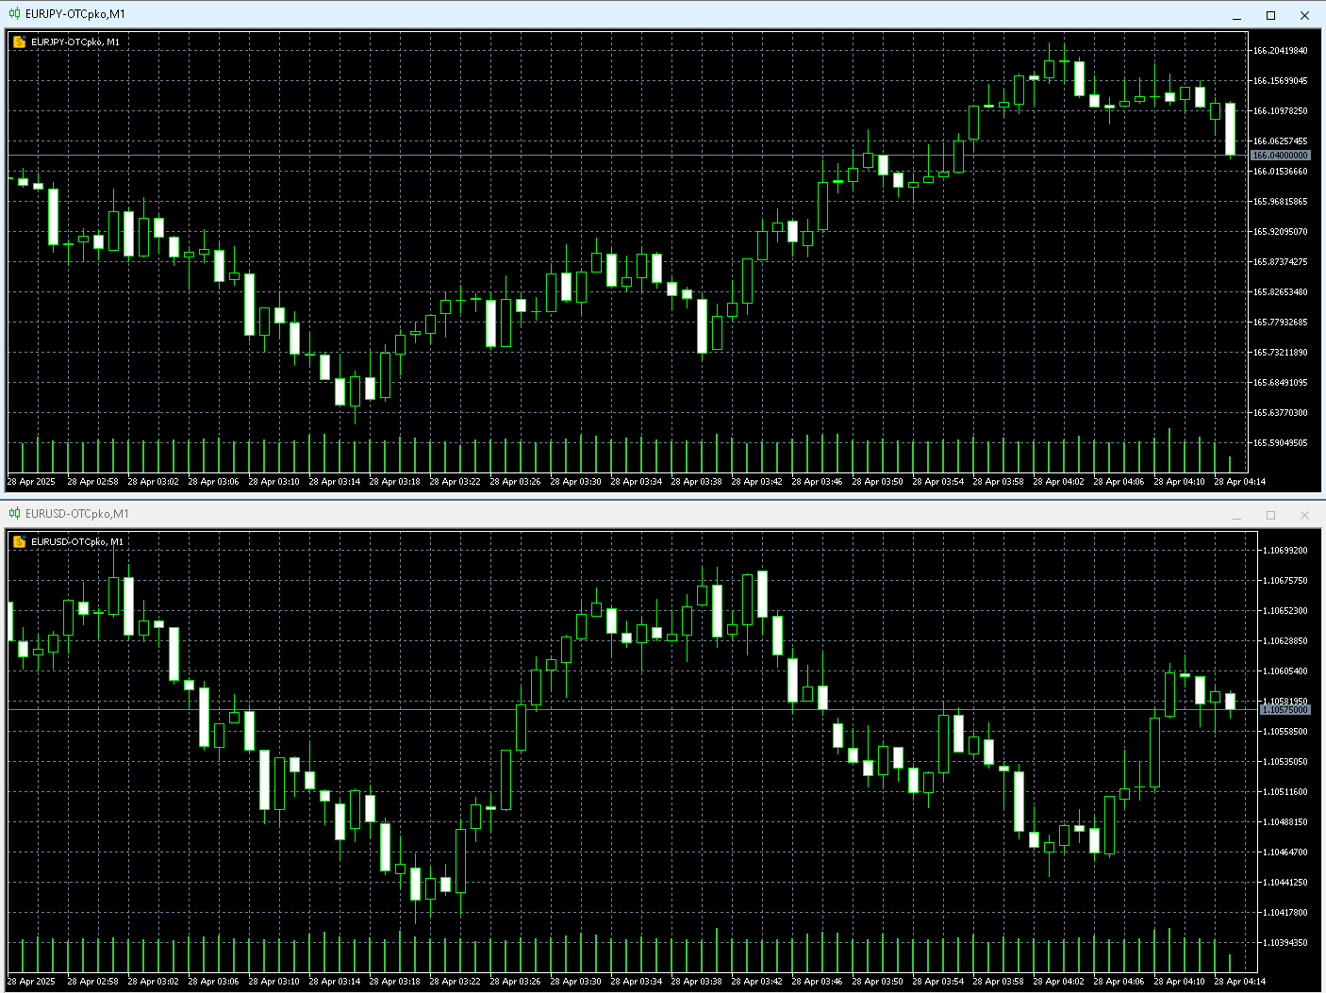

Now this is your choice to either update your candles or Load Heiken Ashi, there is Free Heiken Ashi candles in Examples, just expand and right click and add to chart.

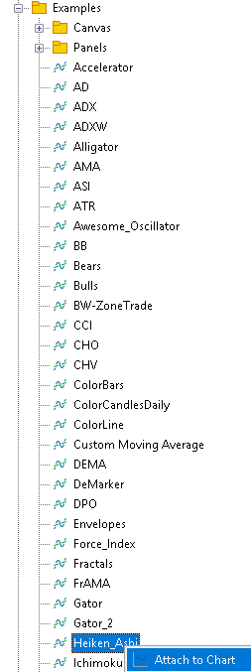

you do not need to use Heiken Ashi, but most of our strategies use Heiken Ashi candles.

Now if you decide to use Heiken Ashi candles you will have regular and Heiken Ashi candles on the same chart, again if can keep it this way, but I prefer to remove those regular candles, just right click on chart then click properties and use the following settings.

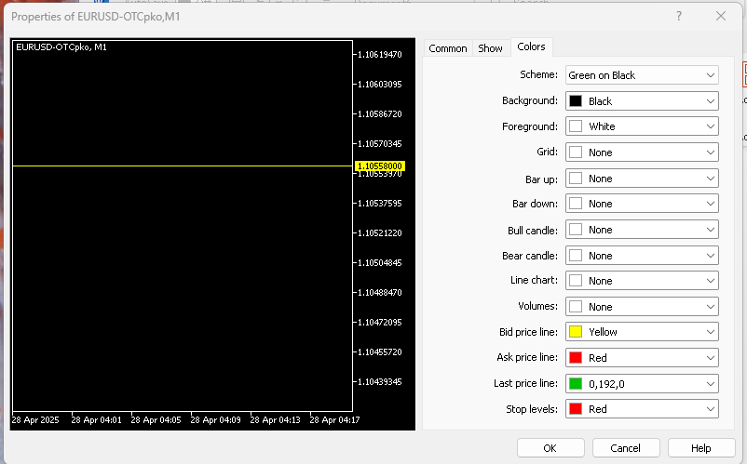

Once you do this only Heiken Ashi Candles will be on the charts

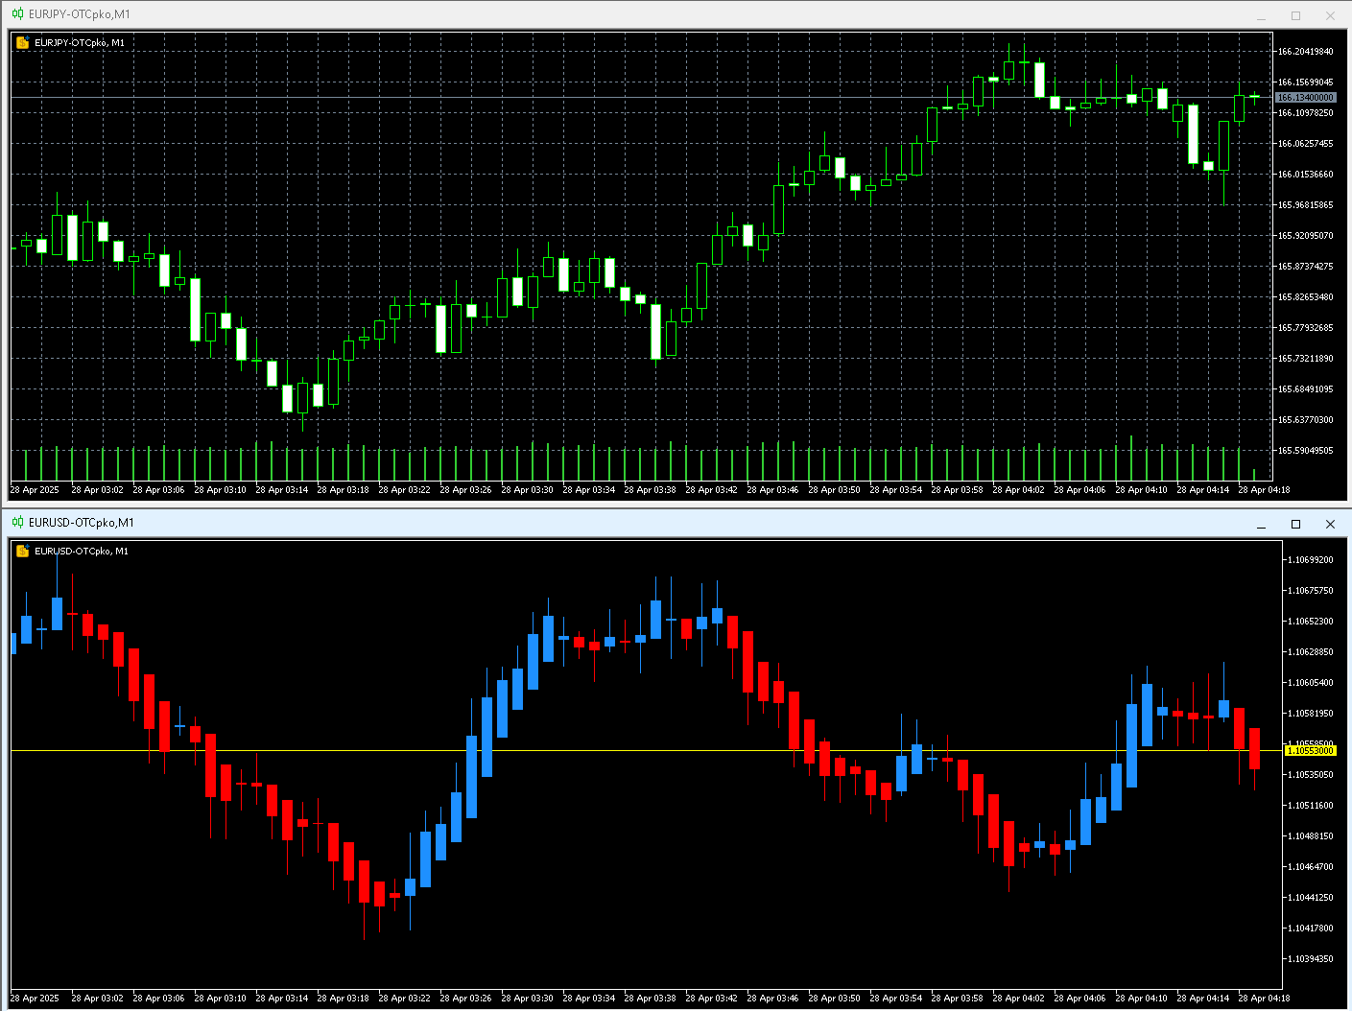

Next, we need to open the Binary Baseline Indicator install and install your Indicator.

Unless you have a License Key you are allowed to install 1 Indicator and use 1 indicator at a time, you may uninstall that indicator but only allowed to uninstall once a day.

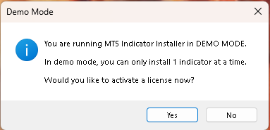at this point click No.

Next the app will list all the indicators we supply, click on anyone and install

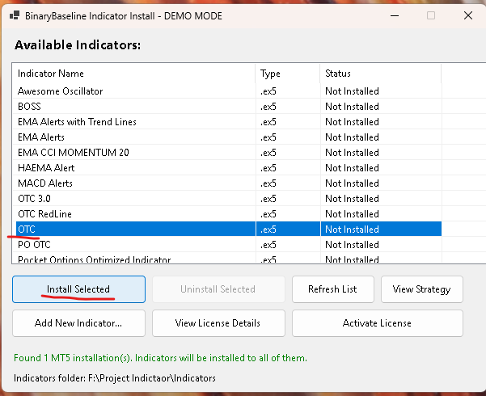

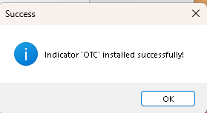

Now once it is installed you need to go back to your MT5 app and Right Click on the Indicator and click REFRESH, once you do that the indicator will appear.

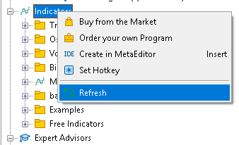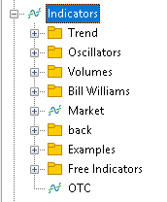

Now that you have it installed, click and attach to chart and adjust your settings.



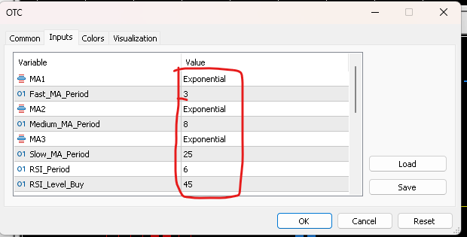

All those settings in RED can be adjusted, we will give you the correct settings to adjust to, for now I will use the default settings.

Now once you add it you will see a bunch of alerts that came through, do not worry about this as it is going through the HISTORY and placing Buy and Sell Icons on the chart or Charts.

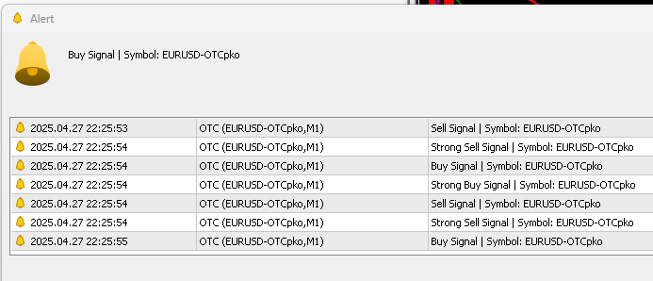

Just click OK and it will close.

An if you look at the charts you will see Icons when to Buy and when to Sell, these are the alerts that will be traded on Pocket options automatically, once we get the Binary Baseline Main app running.

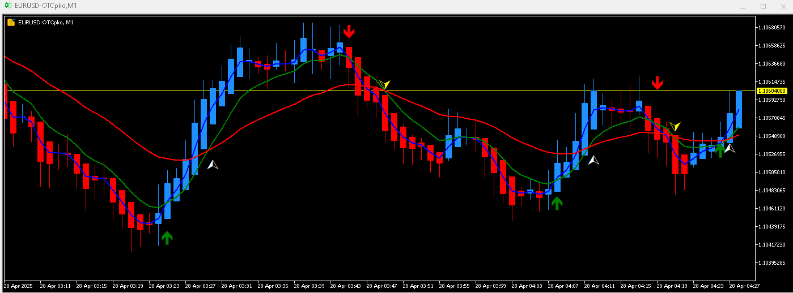

Next you want to do the same for the other charts you have selected.

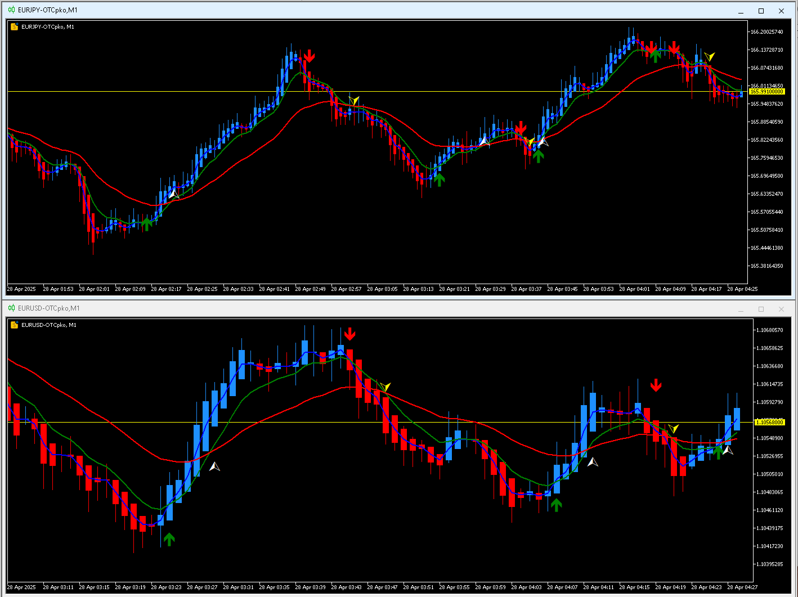

Next we need to load the Binary Baseline App. Find the app in your start menu and open it

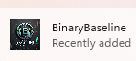

Same deal unless you have a License Key the Main App will only allow you to do 10 Daily Trades, so unless you have a Key click NO.

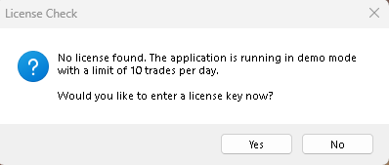

Next sign in with you Pocket Options Account, you may have to do the CAPITCHA, so it doesn’t think you are a ROBOT.

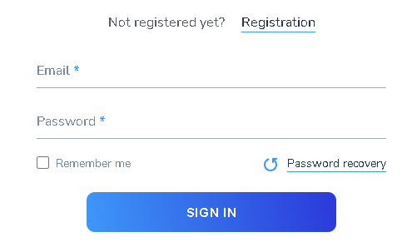

Once it opens either switch to DEMO or stay on Live account, for this demo we will use DEMO account. So click Switch To Demo Account Button

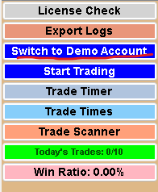

Next you will want to select your Favorite Charts that you have selected on your MT5 app, since we are in demo mode we can only have 2 charts loaded so find those 2 charts and add them to FAVORITES

Click on the STARS to add to your Favorites.

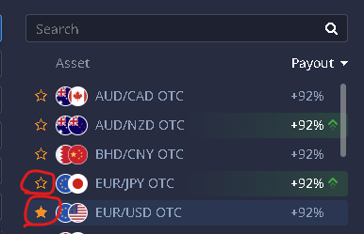

Once you have them setup, adjust your Price and Timeframe, For now I will use $50 and 1 minute charts

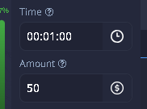

Once that is done, all you got to do is press START TRADING button and that is it, once alerts come through your MT5 app they will Trade on its own,

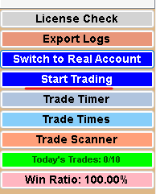

There is a Profit and loss Button which lets you know if you made money or lost, There is also a Win Ratio,



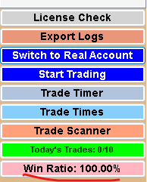

And as you can see you can only do 10 TRADES a day.

Also, while you wait for Automated Trades to come thru, You can use this app to do manual Trades as well, But be **forewarned**, if an Automated trade comes thru it will switch to that chart and place a Trade.

When a Automated Trade does come thru the Alerts Log window will show you Current and Closed Trades in progress or closed.

Now if you do Manual Trades, it **DOES NOT COUNT AS A DAILT TRADE, ONLY AUTOMATED TRADES GET COUNTED.**

**As you can see I did a Manual Trade, but it has not been counted.**

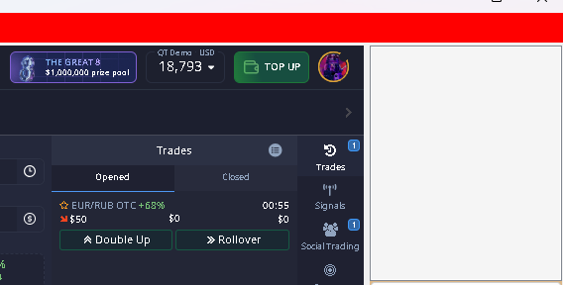

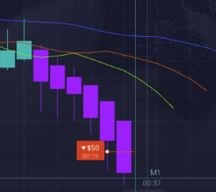 Manual Trade.



As you can see no Daily Trade Counts have gone thru 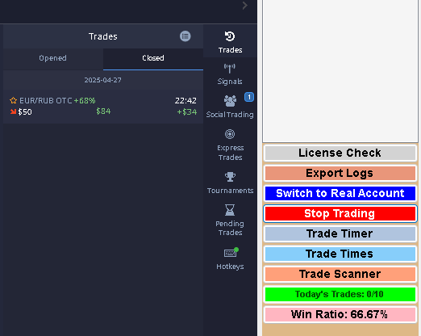

However, The win ratio will still count because your Profit & Loss has Gained money.

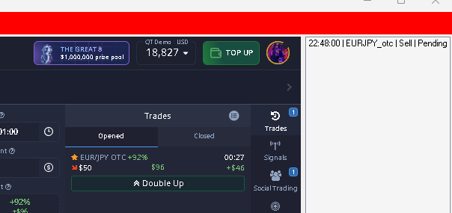

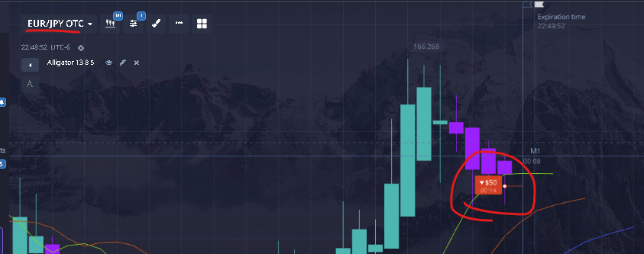

As you can see Alert Logs are showing Pending. As a Automated Trade Came Thru.

And another trade came thru and recorded a loss on the last trade 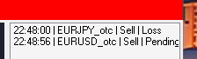 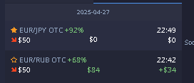

This will continue until you use up all your Daily trades

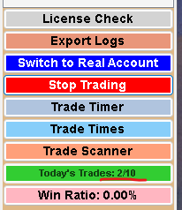 Counter has climbed,

As the Automated Trades Continue the Today’s Trades Button will change color until it reaches the Daily Limit.

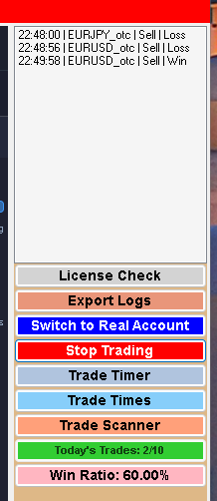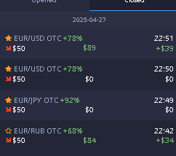













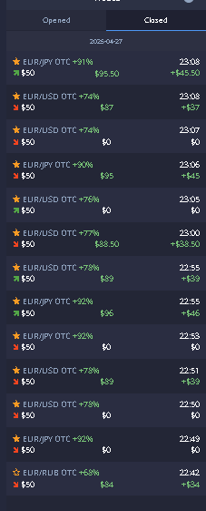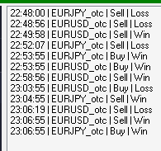

Like I said default Settings and automated trading.

Once you hit your daily Trade Limit the Automated Trades Stop, You can still do Manual Trades if you like, But again that would be up to You.

Good Luck and Happy Trading. 😊